Please pay subscription fee by one of the means below and tick box to indicate payment method:
- enclose a cheque payable to Marches Meadow Group

- bank transfer to NatWest Bank sort code 51-61-06, account number 76814041*

- set up a standing order using the above account details*

* If paying by bank transfer or standing order please give your name as the reference
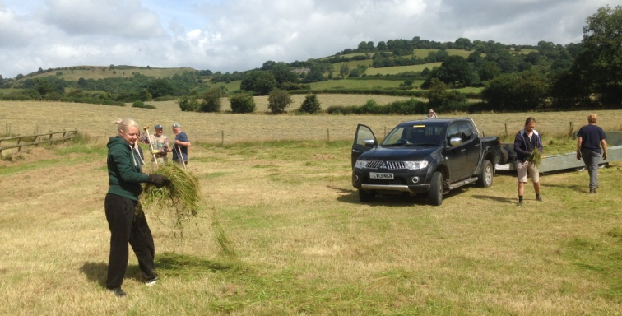
The Marches Meadow Group focuses on the area from Pontesbury in the north to Clun in the south and from Montgomery in the west to Church Stretton in the east.
Members from outside this area are welcome but the services of the contractors may not be available outside the area described.

MMGW

Version 16 May 2022
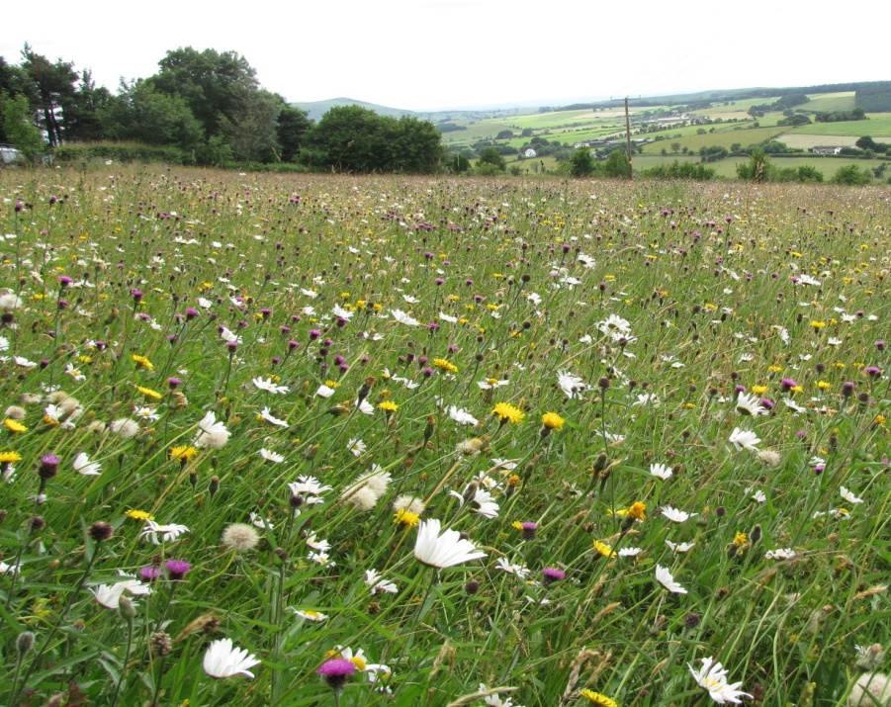
The aims of the Marches Meadow Group are to:
- Promote the conservation of existing species-rich meadows
- Increase the number and area of species-rich grasslands through appropriate enhancement
- Support meadow owners with advice and access to small scale hay-making machinery
- Publicise the beauty and value of wildflower rich meadows and their associated animals
- Give advice and support to create just a small patch of meadow in your garden

Marches Meadow Group offers:
For everyone
- Conservation and enhancement of meadows and other grasslands, including lawns, road verges & public open spaces
- Publicising the threats to meadows and the measures that can be taken to save them
- Workshops, visits and talks on aspects of meadows
- Social occasions – meet with other meadow enthusiasts
- Website (www.marchesmeadowgroup.com) & Facebook group (www.facebook.com/groups/463777554459852/)
- For meadow owners
- A survey of the plants of your meadow(s)
- Advice on the management of your meadow(s), including livestock if desired
- Access to the small-scale hay making machinery owned by the MMG & operated by MMG’s contractor
- Help from other members of MMG (in return for your help!)
- Opportunity to enhance the diversity of your meadows through green hay or seed sowing
- Co-ordination of green hay donor and recipient sites
- Access to markets for hay meadow products – buying or selling
- Site visits to other meadow managers’ meadows
For general enquiries please telephone 01743 791476 or e-mail richard.w.small@gmail.com
Annual membership subscription: £20.00
(If joining between January and May subscription extends to second AGM after joining)
Marches Meadow Group
Membership Application Form
Name:

Address:

Post code:

Telephone no.:

E-mail:

These details will be used only for Marches Meadow Group matters; please tick the box to indicate your acceptance of these terms under the General Data Protection Regulation

How did you first learn about Marches Meadow Group?

Date:

Signature:
Please return the completed form to: Ms. S. Reedy, Meadow House, Habberley, Shrewsbury SY5 0TR. Payment methods shown overleaf.

